

***PRACTICAL FILE***

**NAME: ANIMESH JAIN**

**CLASS: CSE DEVOPS 4th SEM B-1**

**ROLL NO.: R171218022**

**SAP ID: 500069453**

**Subject: Build and Release Management**

**Index**

|  |  |  |
| --- | --- | --- |
| **S. NO.** | **Experiment** | **Page NO.** |
| **1** | **Create a java project using Maven** | **3-4** |
| **2** | **Unit Testing using Junit tool** | **5** |
| **3** | **Maven Build and usage in other Java Project** | **6-8** |
| **4** | **Install and Manage Maven Plugin Install Site Plugin** | **9-10** |
| **5** | **Working with Maven Repository** | **11-12** |
| **6** | **Create a simple Maven Project using CLI** | **13-16** |
| **7** | **Selenium WebDriver Perform Automation testing using Selenium Web Driver for testing a web page** | **17-20** |
| **8** | **Selenium IDE. Perform Automation testing using Selenium IDE for testing a web page.** | **21-24** |
| **9** | **Build Profile using maven** | **25-27** |
| **10** | **Integration using GitHub Create a complete Maven project and push in GitHub repository for Continuous Integration.** | **28-29** |
|  |  |  |
|  |  |  |
|  |  |  |

**Experiment 1**

**Aim:**

**1.Create a Java Project using Maven.**

**2.Run the following maven goals on this project**

**3.Clean**

**4.Compile**

**5.Test-Compile**

**6.Install**

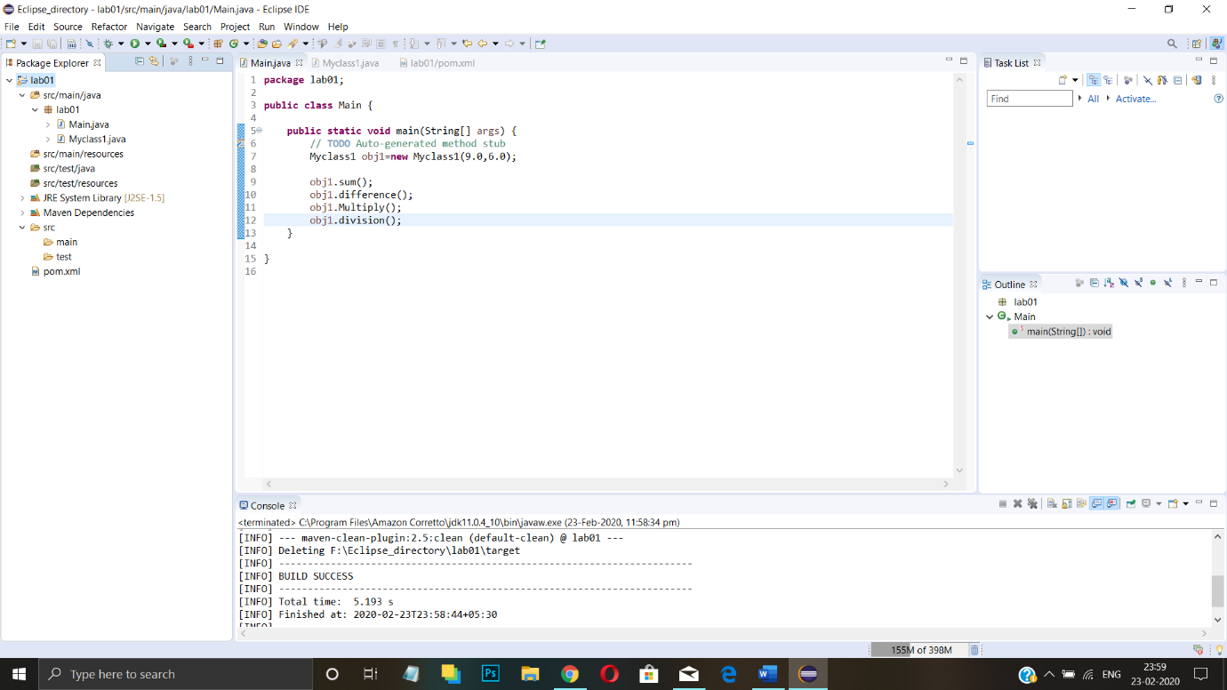

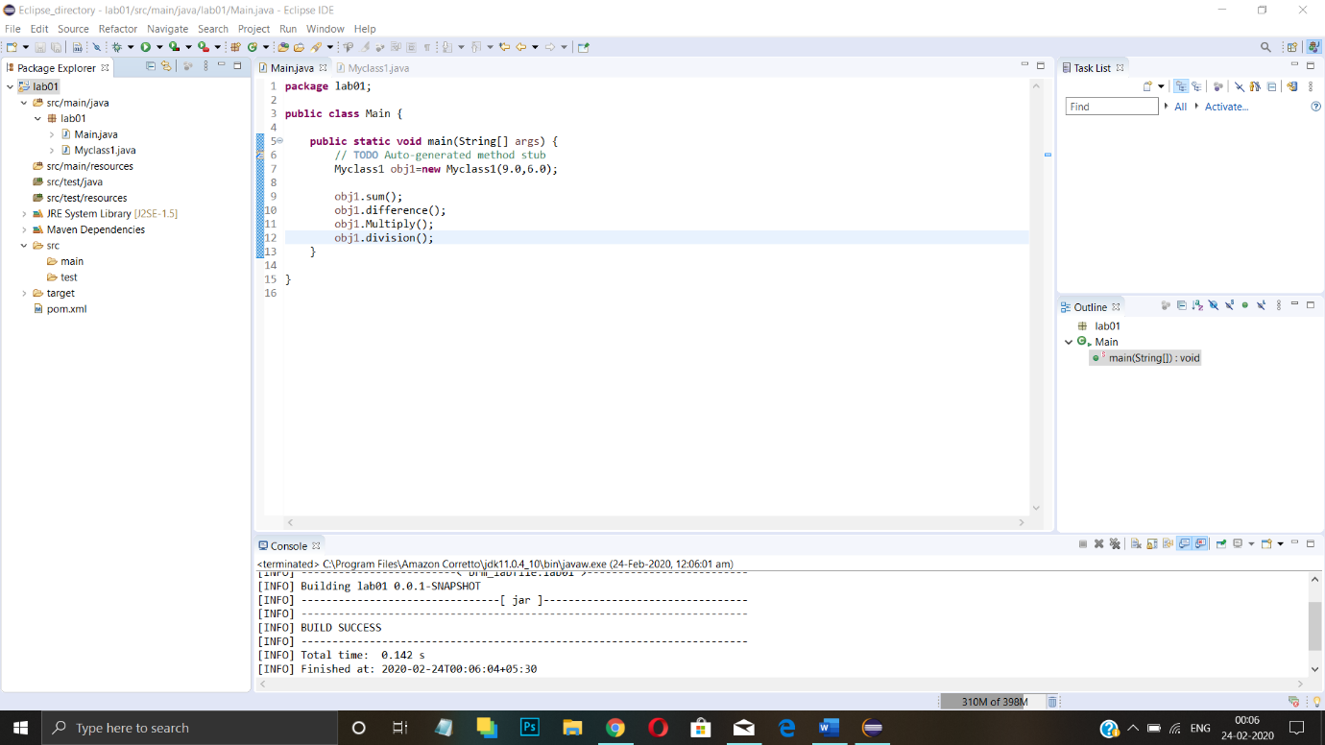

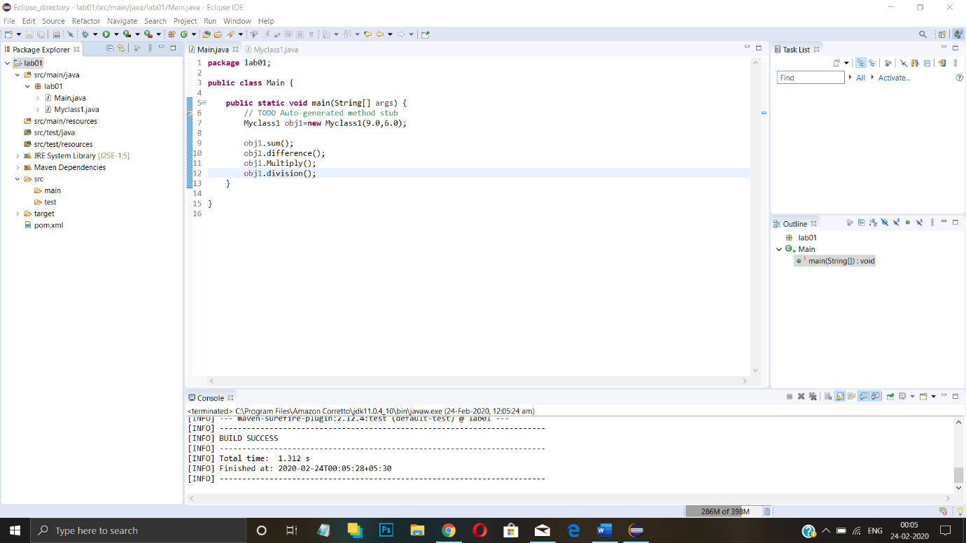

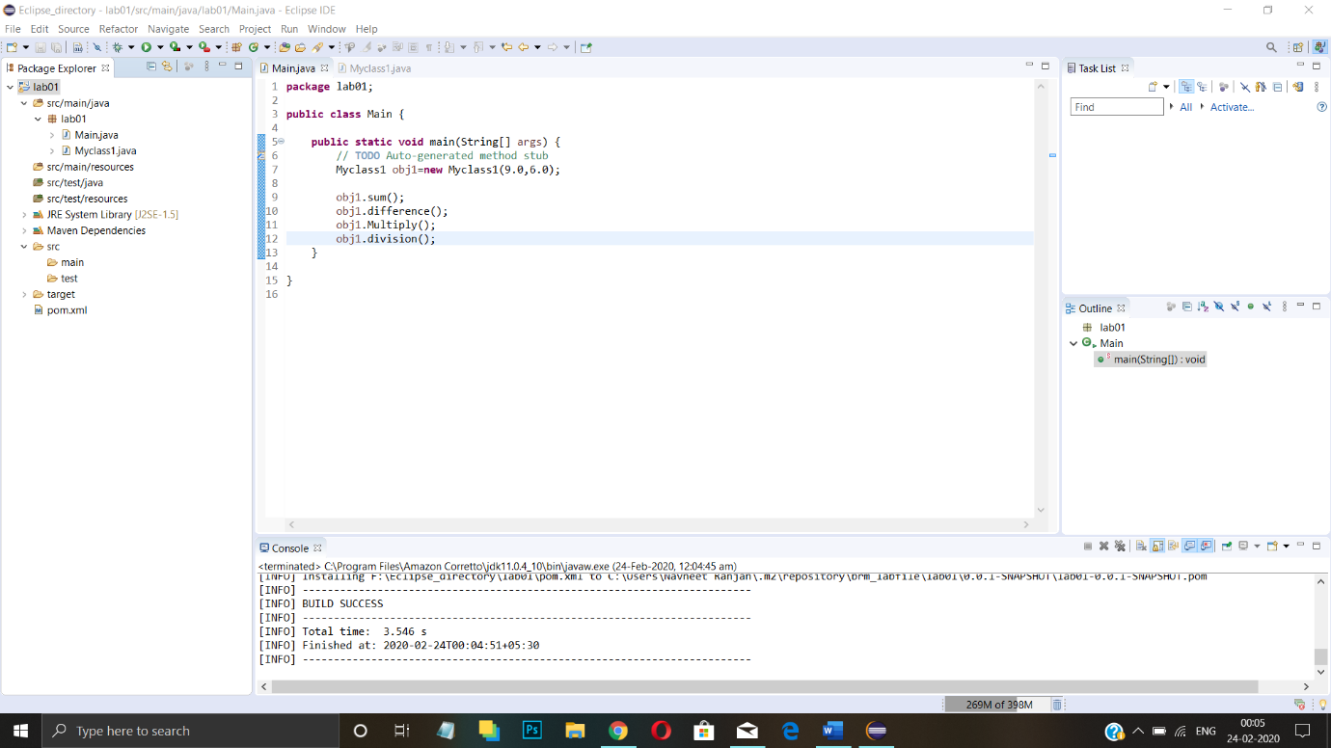

**Experiment 2**

**Aim: Unit Testing using Junit tool**

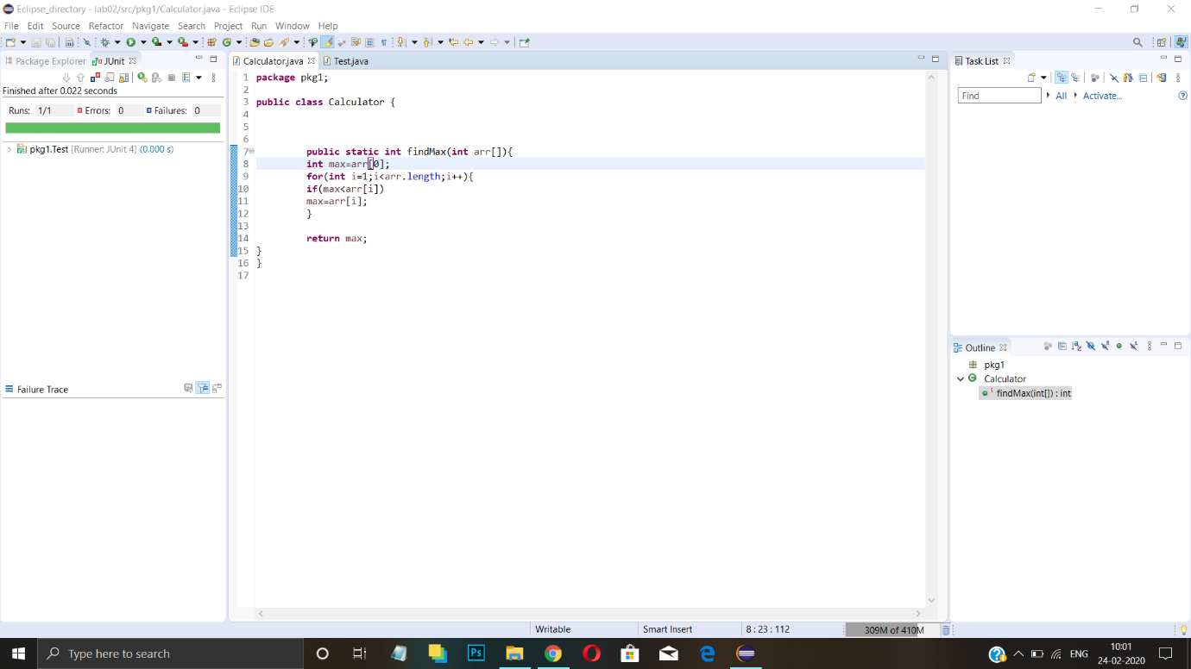

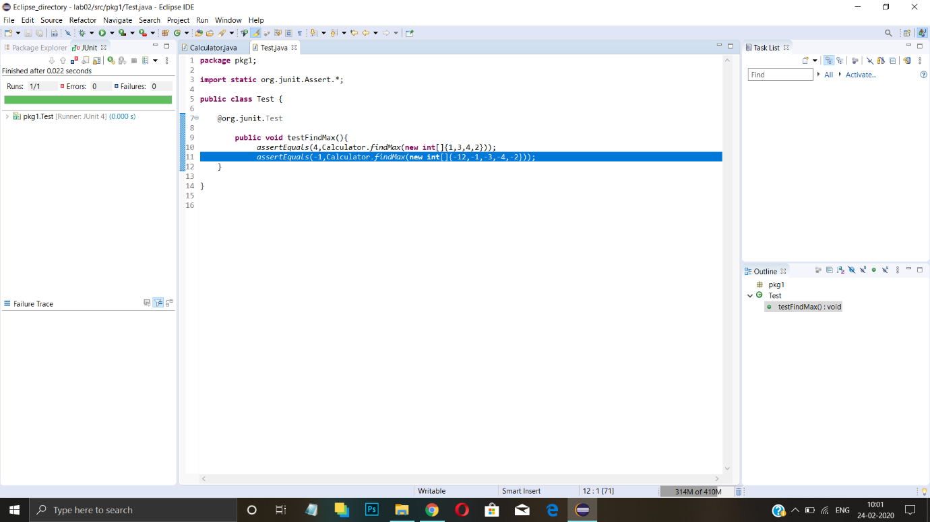

**Experiment 3**

**Aim: Maven Build and usage in other Java Project**

**1. Create a Build of java project using maven.**

**2. Use that build in some other Java Project.**

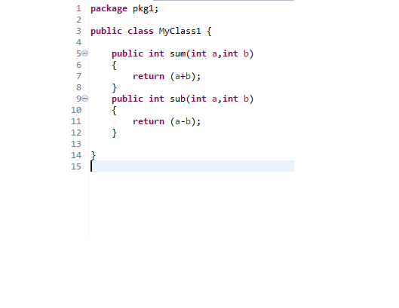

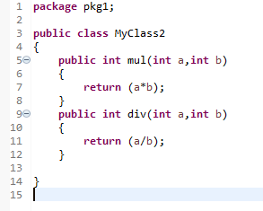

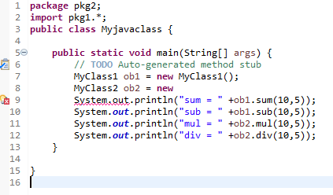

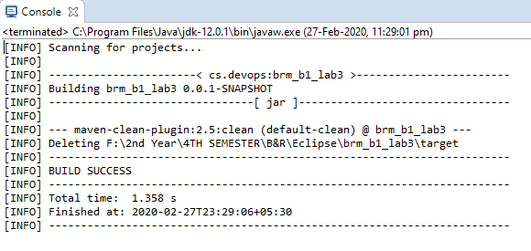

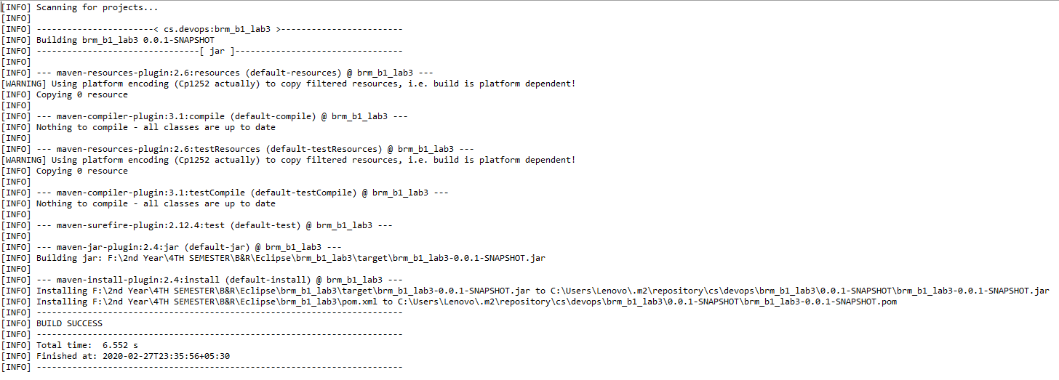

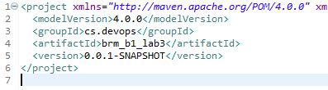

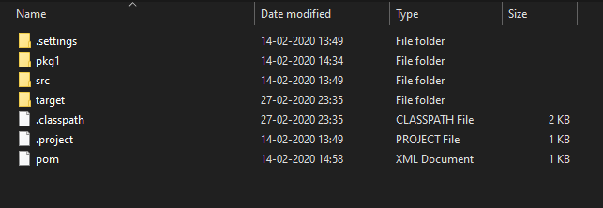

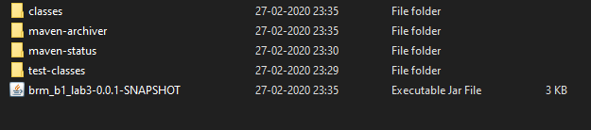

**Experiment 4**

**Aim: Install and Manage Maven Plugin Install Site Plugin and use “mvn site” command and goal for generating documents for Maven Project.**

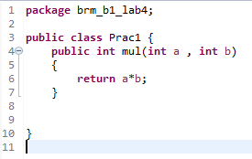

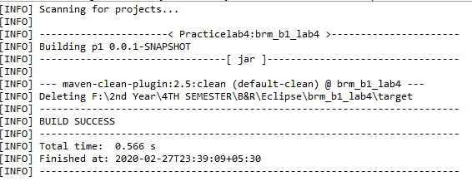

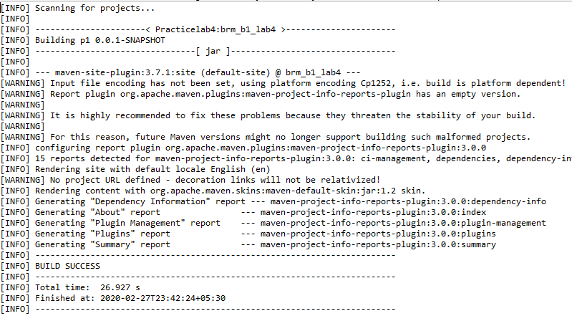

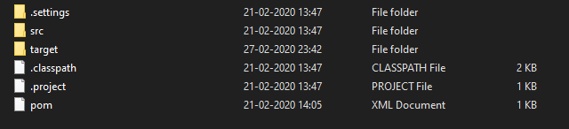

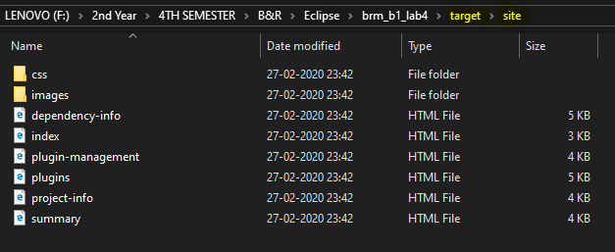

**Experiment 5**

**Aim: Working with Maven Repository**

**1. Add Central Repository (Hibernate)**

**2. Add Remote Repository (Atlassian Mail)**

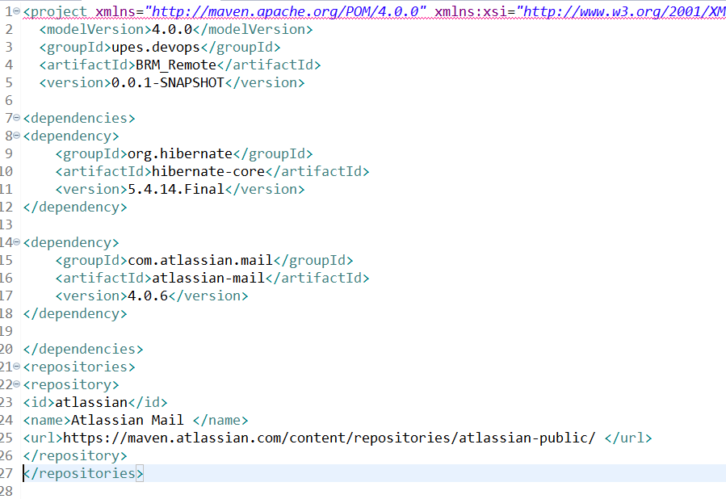

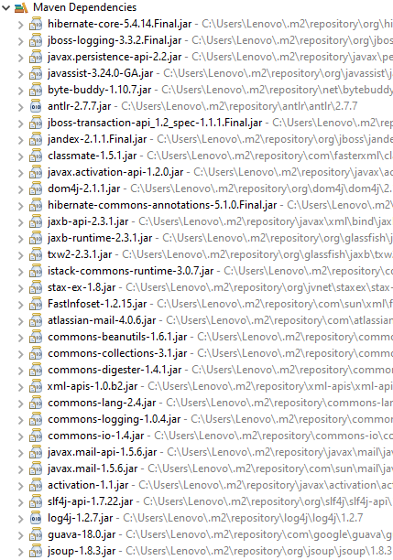

**Experiment 6**

**Aim: Create a simple Maven Project using CLI**

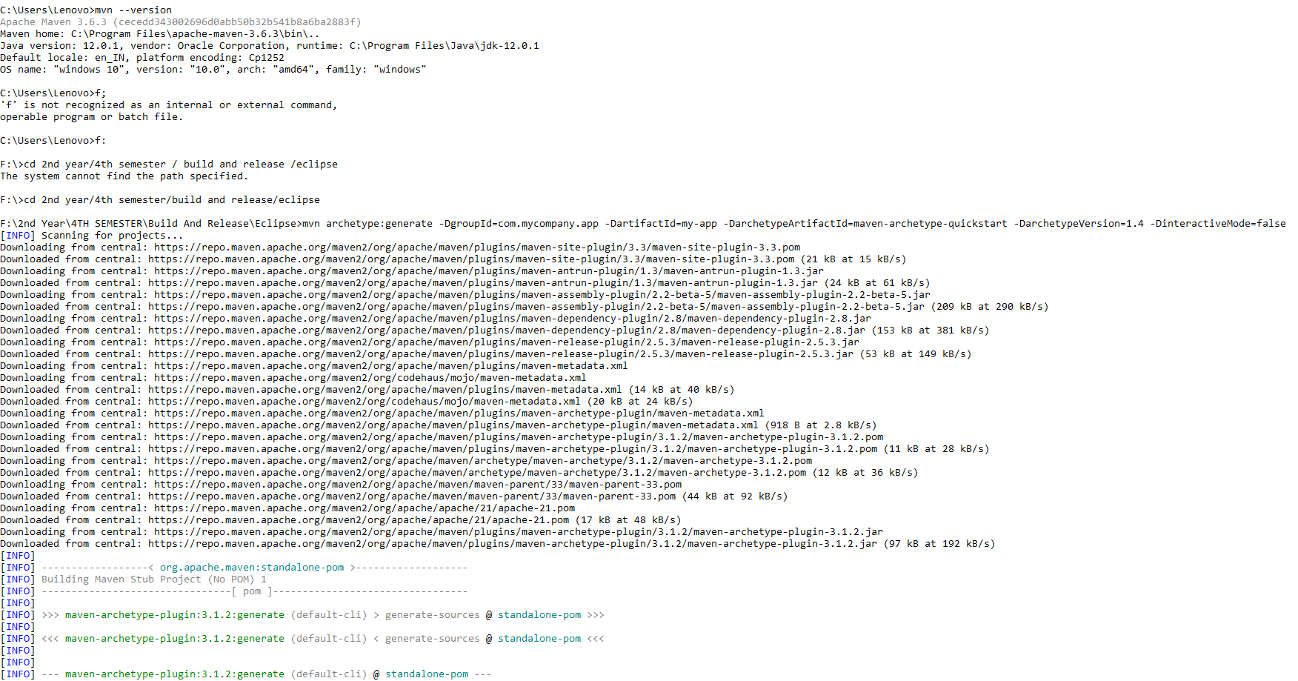

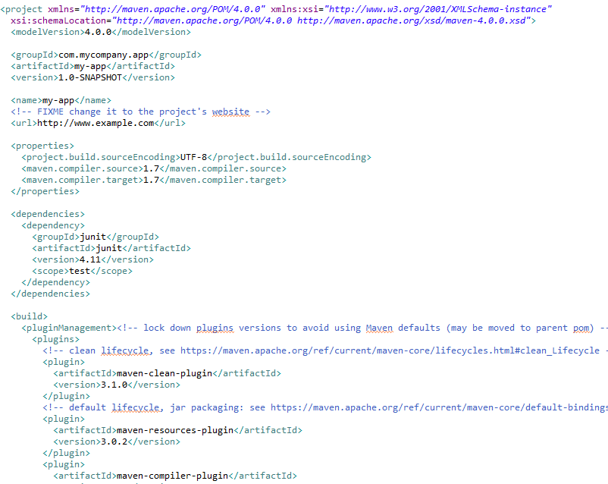

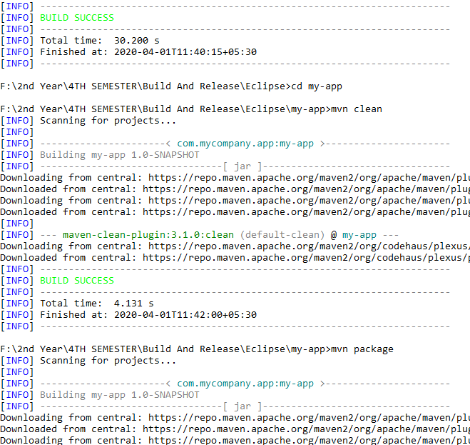

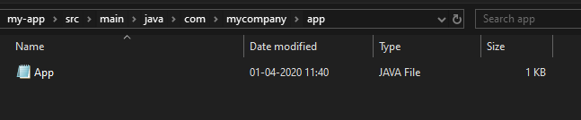

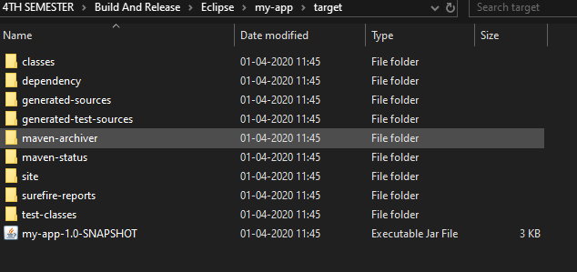

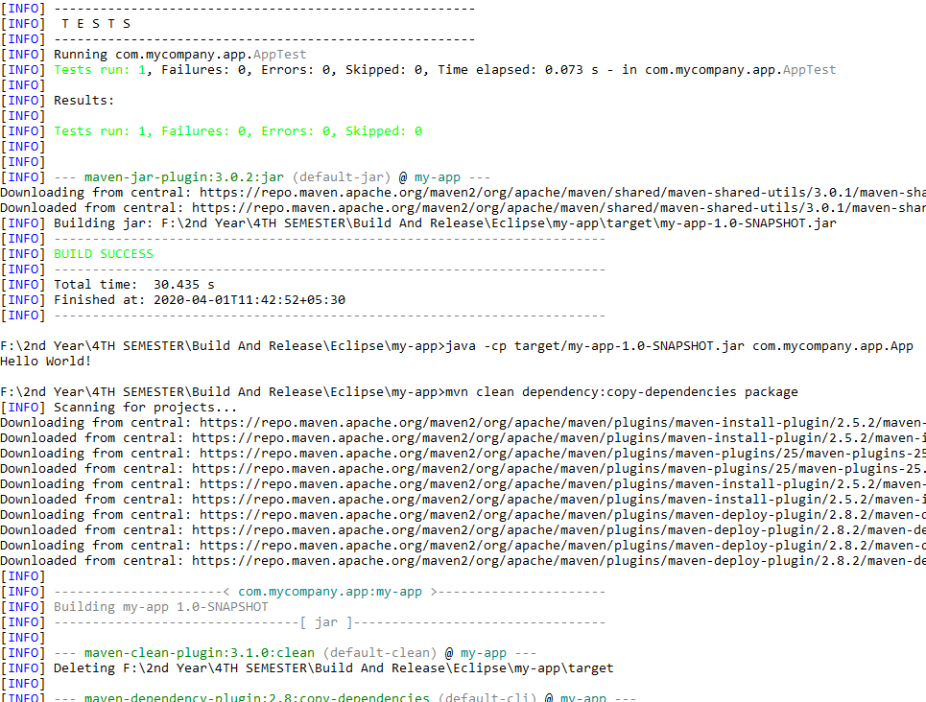

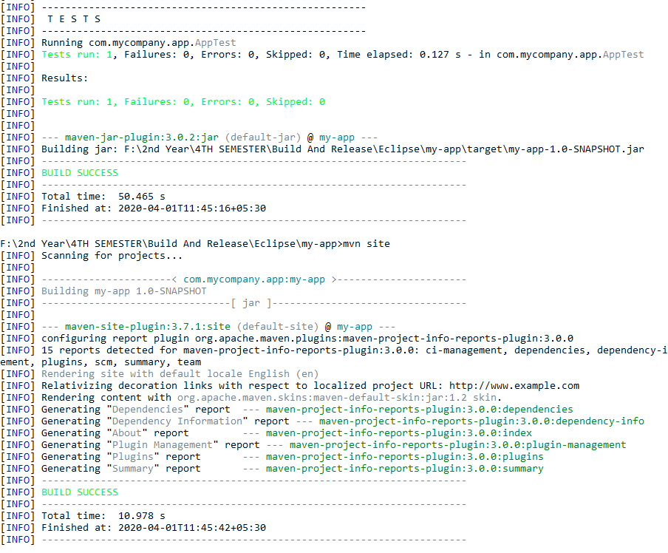

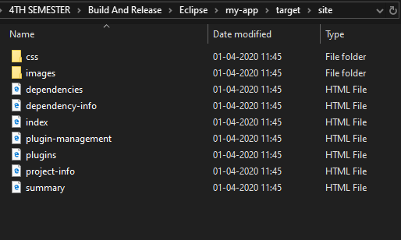

**Experiment 7**

**Aim: Selenium WebDriver Perform Automation testing using Selenium Web Driver for testing a web page.**

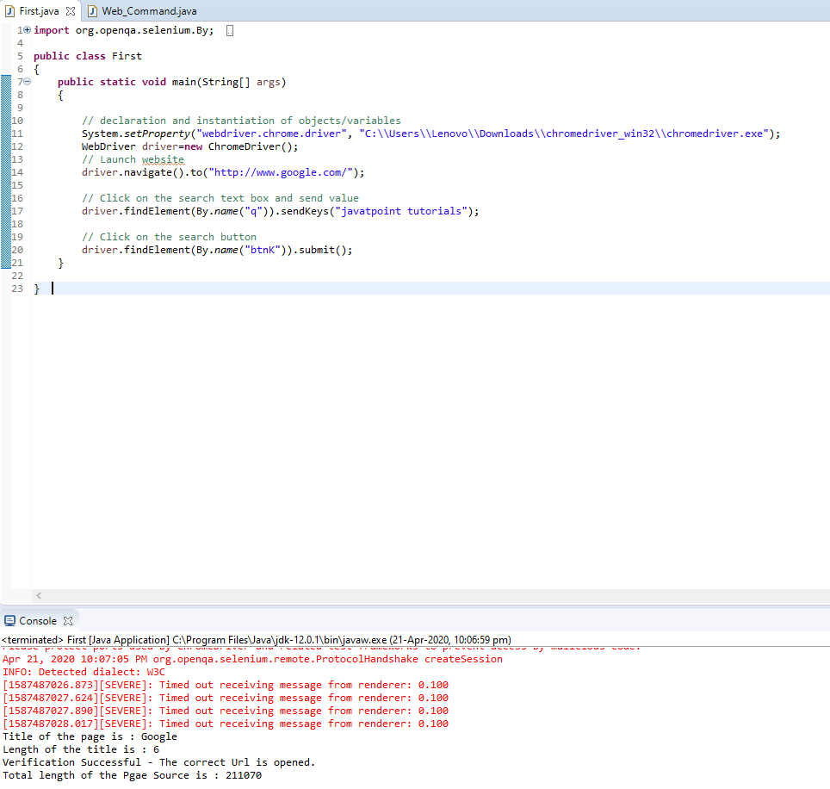

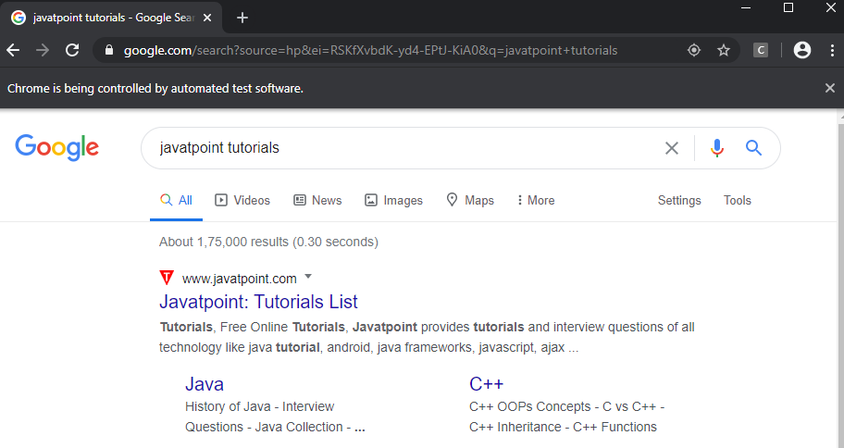

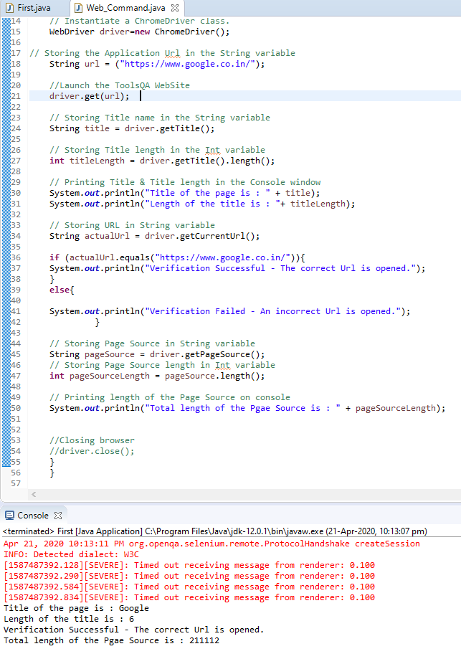

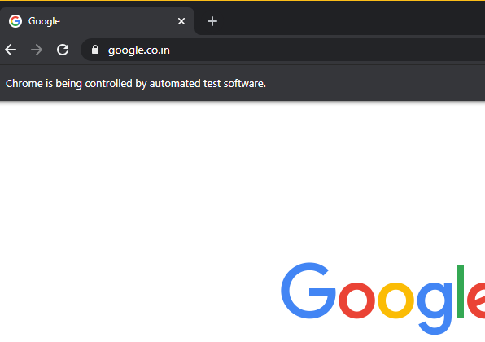

**Experiment 8**

**Aim: Selenium IDE. Perform Automation testing using Selenium IDE for testing a web page.**

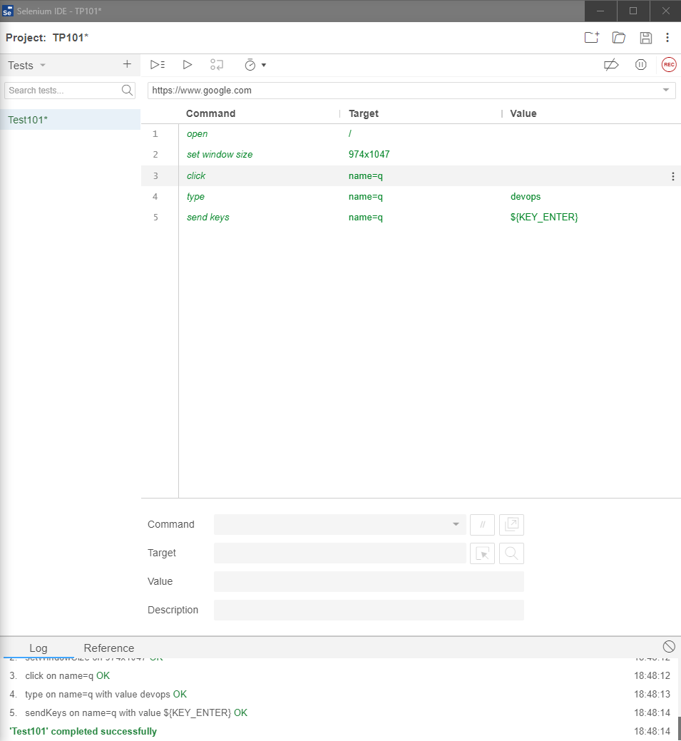

run

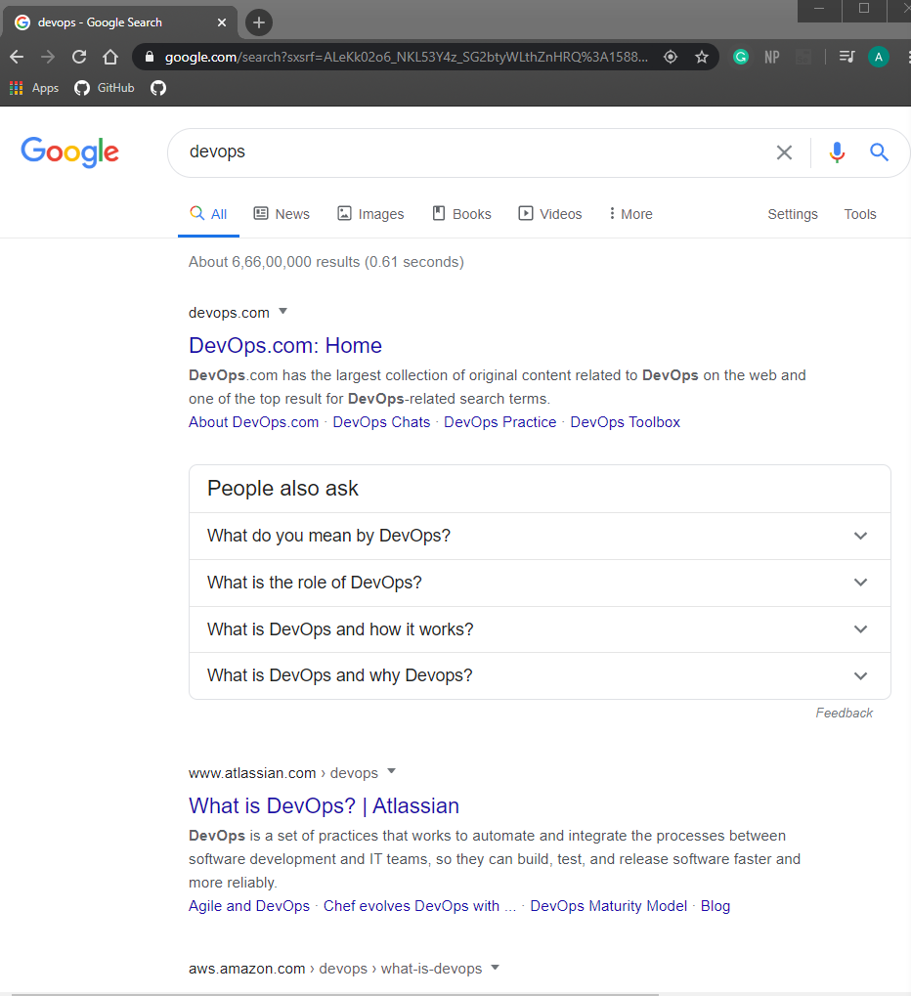

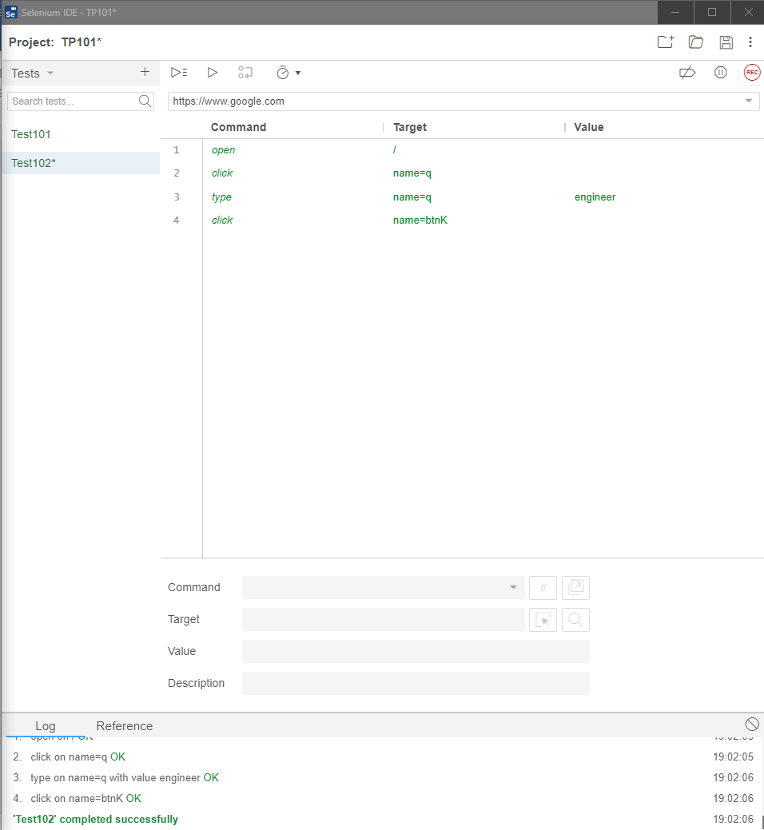

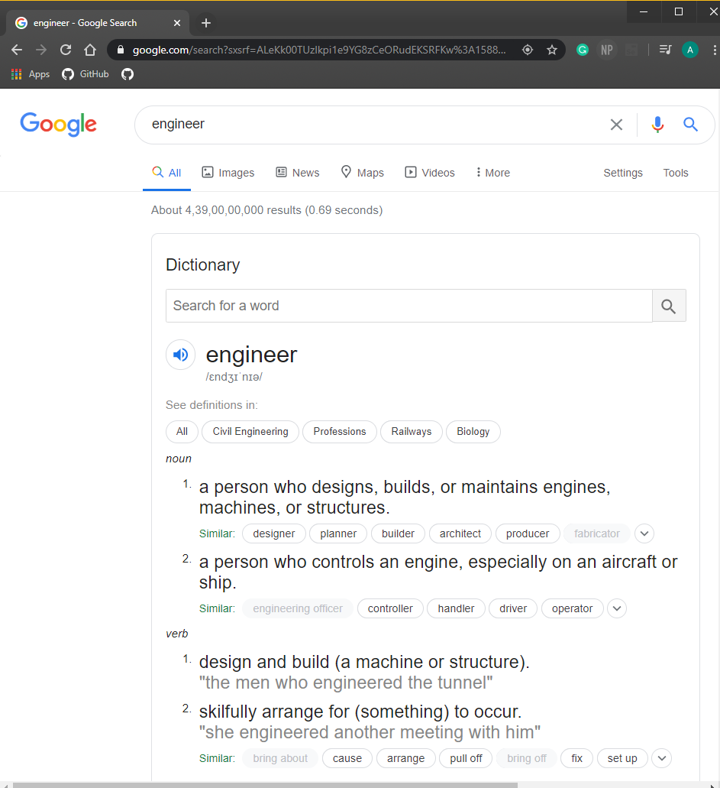

**Experiment 9**

**Aim: Build Profile using maven**

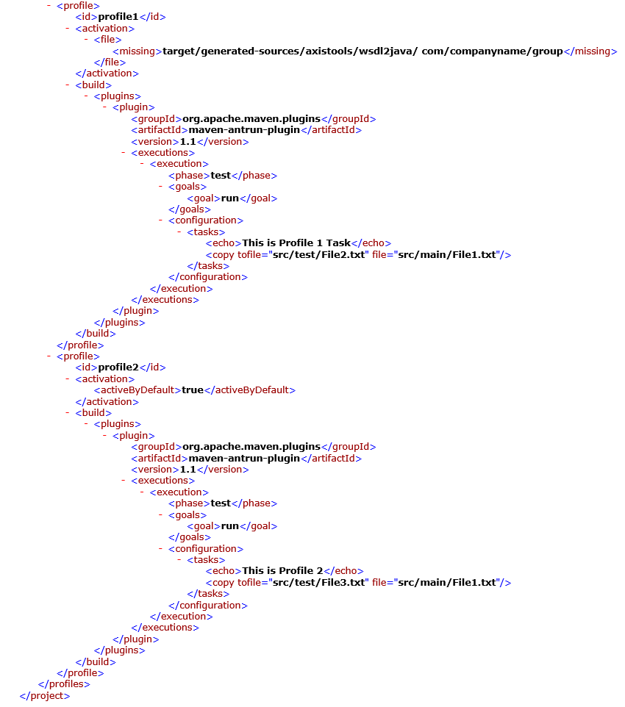

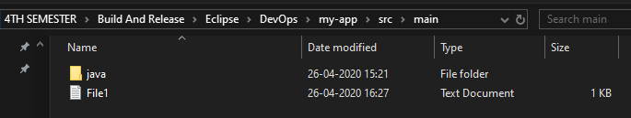

**Command Run : mvn test -Pprofile1**

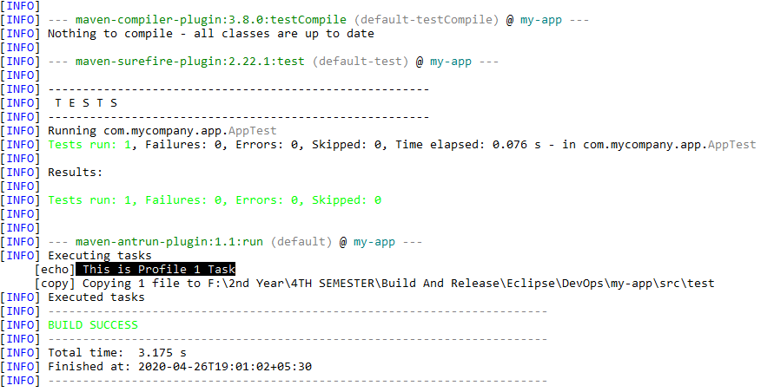

**Command Run : mvn test -Pprofile2**

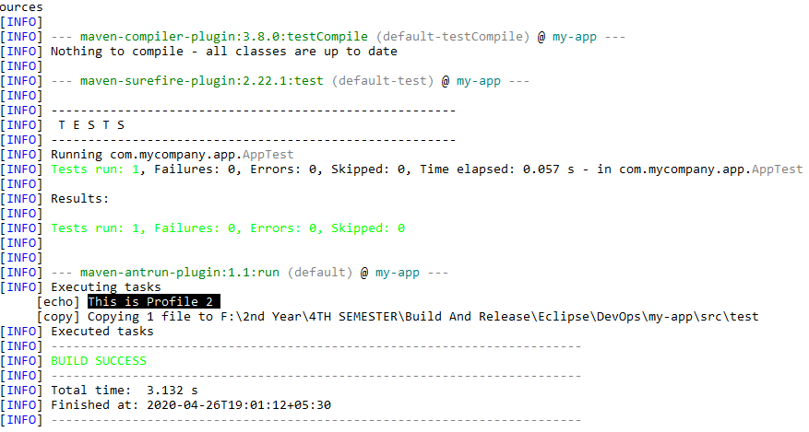

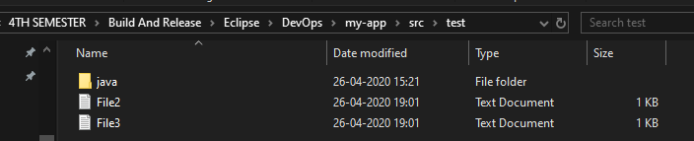

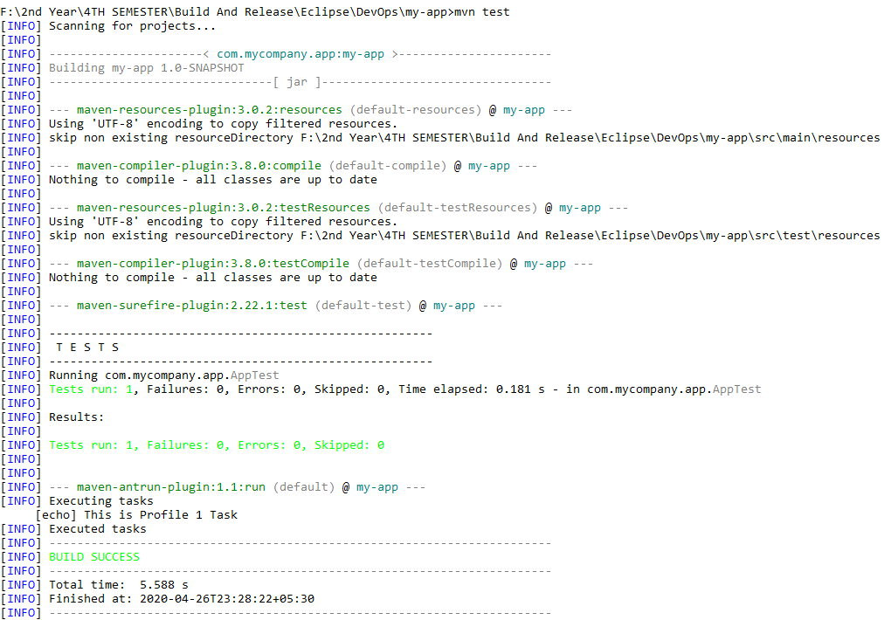

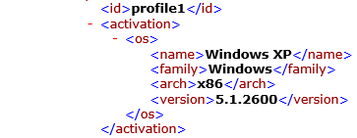

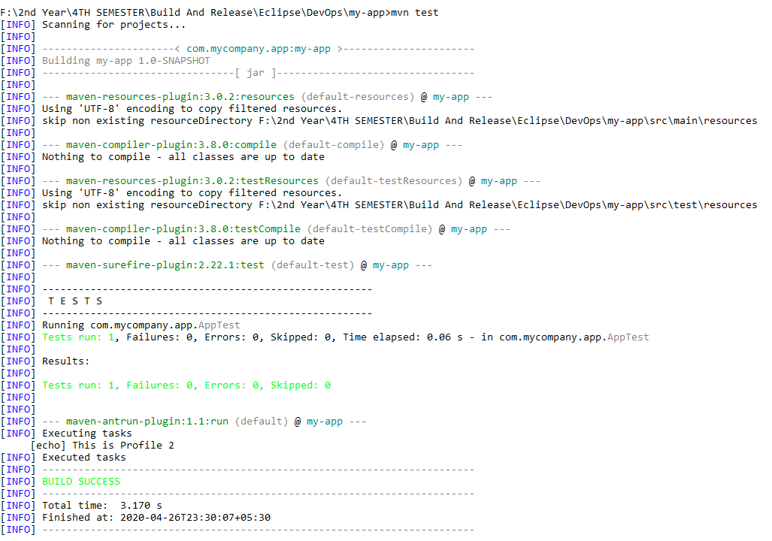

**Experiment 10**

**Aim: Integration using GitHub Create a complete Maven project and push in GitHub repository for Continuous Integration.**

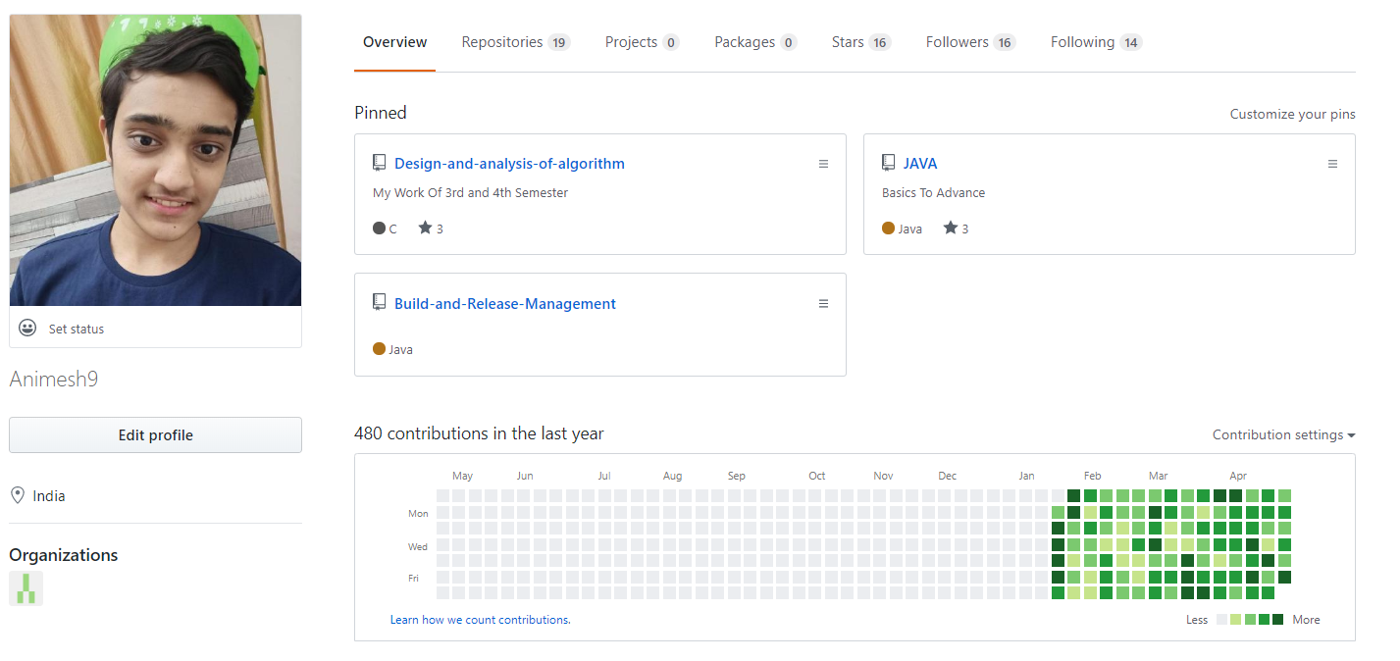

Click [here](https://github.com/Animesh9/Build-and-Release-Management) to check my Github account.

